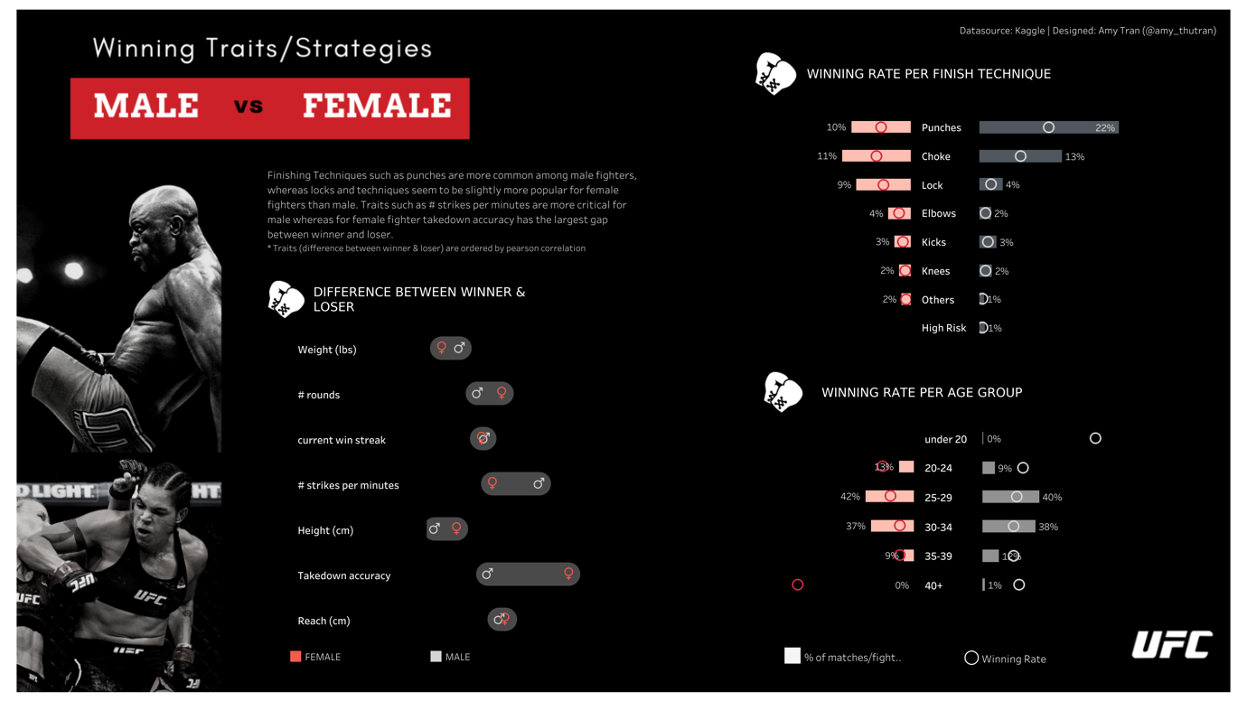

Link: <https://public.tableau.com/app/profile/amy.tran3167/viz/SportvizSunday-MalevsFemaleFighters/UFC>

Visualisation 1: Difference between winner & loser

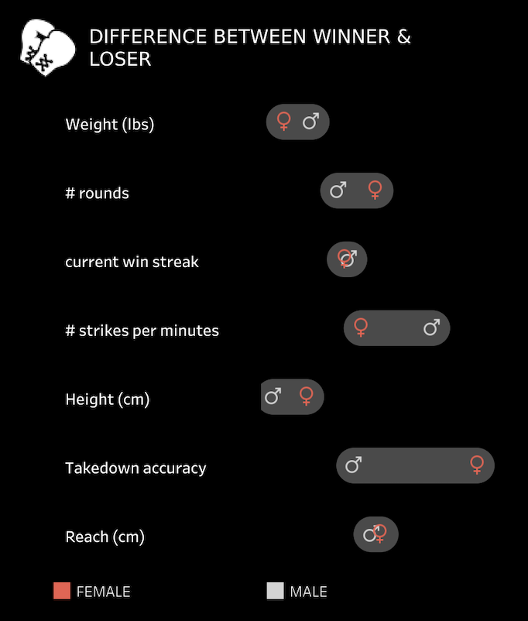

Visualisation idiom: Connected dot plot

Mark(s): Points to represent the male and female attributes

Channel(s): Horizontal position and hue to represent the male and female attributes

Discuss: The idiom is not a really good choice since there are multiple attributes has been shown, it doesn’t have any common scale which might confuse the reader to know the exact difference between female and male’s attributes. Although the plot is a good use to compare male and female, I would say the connected plot is not suitable for this situation

What?

Datatypes: Categorical data for the group of traits, Quantitative data for each of the traits

Dataset types: Table

Why?

To Query -> Identify and compare the difference between male and female’s traits

How?

Mark(s): Points to represent the male and female attributes

Channel(s): Horizontal position and hue to represent the male and female attributes

Visualisation 2: Winning rate per finish technique

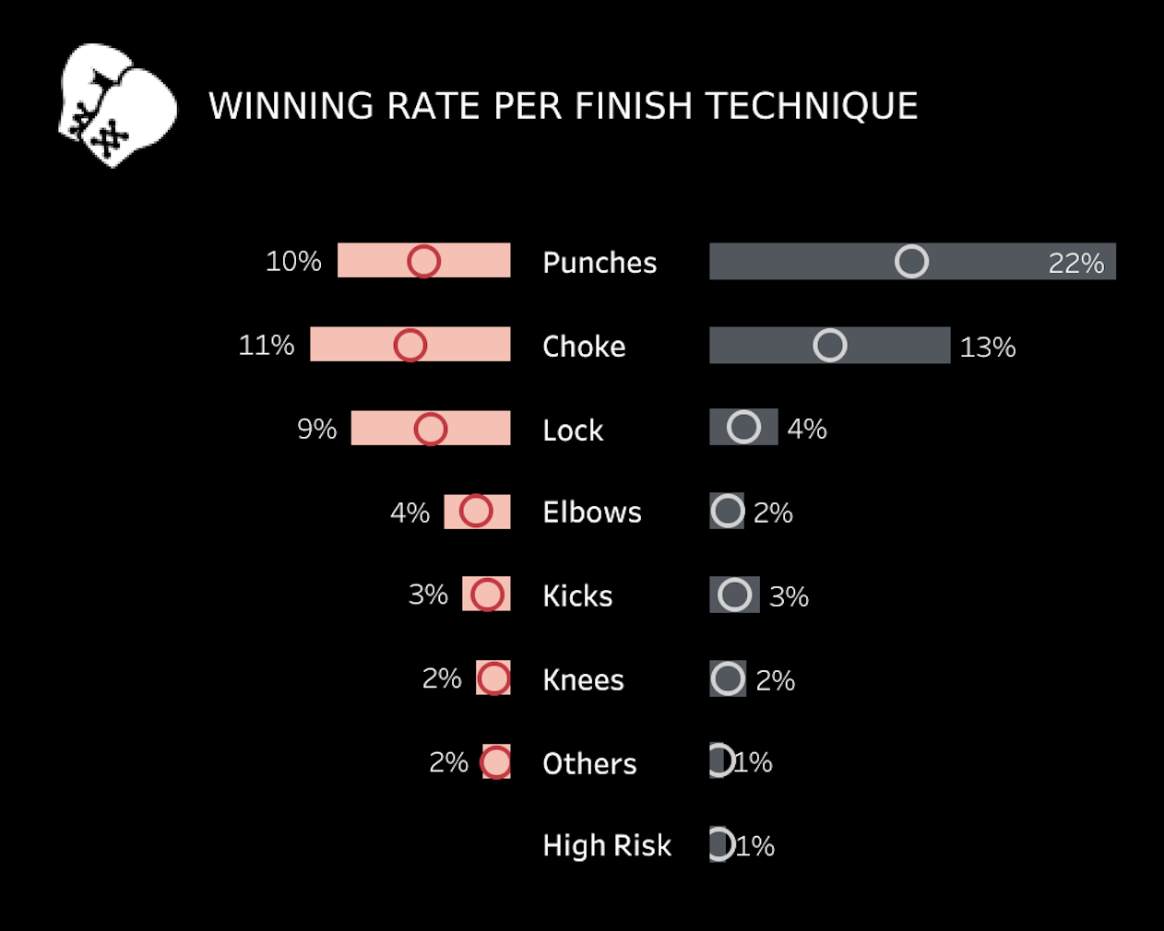

Visualisation idiom: Stacked bar chart and dot plot

Mark(s): Point and line

Channel(s): Colour hue and horizontal position

Discuss: The combination usage of stacked bar chart and dot plot would be a good choice since we could see the comparison between each of the traits

What?

Datatypes: Categorical data for the group of traits, Quantitative data for each of the traits

Dataset types: table

Why?

To Query -> Identify and compare the difference between male and female’s traits

How?

Mark(s): Point and line

Channel(s): Colour hue and horizontal position

Visualisation 3: Winning rate per age group

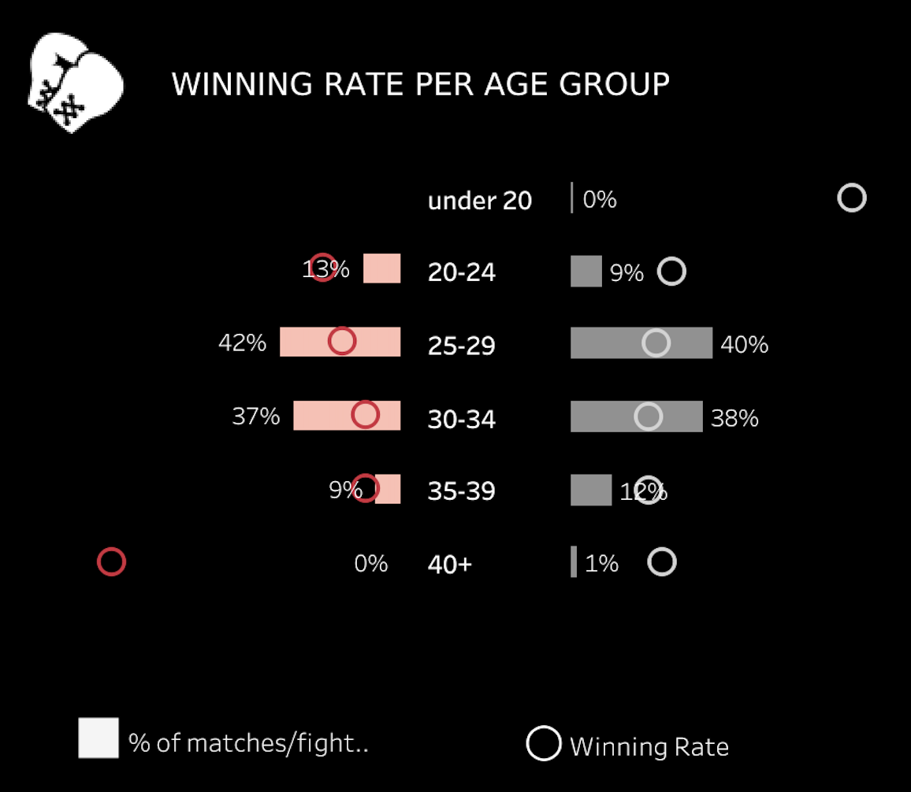

Visualisation idiom:

Mark(s): Point and line

Channel(s): Colour hue and horizontal position

Discuss: The combination usage of stacked bar chart and dot plot would be a good choice since we could see the comparison between each of the traits

What?

Datatypes: Categorical data for the group of traits, Quantitative data for each of the traits

Dataset types: table

Why?

To Query -> Identify and compare the difference between male and female’s traits

How?

Mark(s): Point and line

Channel(s): Colour hue and horizontal position